# Shelf Stocking Operations:

1. Clerks and order fillers pack clients' purchases, price products, replenish shelves with merchandise, and fill mail and phone orders. They work in retail outlets such as grocery stores, hardware stores, and department stores, as well as warehouses. Controlling your inventory allows you to build a clear method for when stock is returned or damaged, preventing the erroneous material from being sent out to customers. A stock management system will assist the warehouse personnel in properly processing products and assigning them to the appropriate areas.
2. Stocktaking allows you to keep an exact record of your physical stock, what has sold and what has not. It all comes down to comparing the physical stock to what the report states and then identifying any anomalies. The majority of firms have raw material inventory warehouses adjacent to their manufacturing facilities where raw materials, consumables, and packing materials are stored and issued on a just-in-time basis. The reasons for keeping inventory differ from instance to case.
3. Operations management is the process of converting inputs (labour, capital, equipment, land, buildings, materials, and information) into outputs (goods and services) that bring value to customers. To fulfil consumer needs, all firms must seek to improve the quality of their transformation processes.

Often, a single organisation must transform all three forms of input - materials, information, and consumers. Withdrawing money from a bank account, for example, requires information on the customer's account, resources (such as checks and currency), and the customer. His consulting partners had bought him out for a pittance, but it was enough to put down on a Budgens store in Crouch End, north London, in 2006.

1. In addition to their day-to-day production responsibilities, operations managers are heavily involved in strategy. We have outlined some critical strategy and tactics elements below, ranging from process design and testing to promoting interdepartmental collaboration Data Analytics are critical for effective planning, modifications, and decision making. Efficiency measurements and effectiveness metrics are the two most popular forms. Data is frequently segregated, making comparison difficult. However, newer systems and configurations make this process easier and allow analysts and managers to study data in novel and beneficial ways.
2. An Operations Manager's specific responsibilities include developing strategy, enhancing performance, acquiring materials and resources, and ensuring compliance. You should be prepared to mentor your team members, develop ways to improve customer service quality, and adopt best practices at all levels. Andrew's marriage did not last long. After his life was turned upside down, he began to investigate personal growth in search of purpose and meaning. He didn't buy a sports vehicle or stock a cellar with whiskey since he was not materialistic. Instead, because business is his passion, he purchased two supermarkets.
3. A CRM strategy aids in the development of improved internal communication inside the organisation. Sharing client data between departments allows you to operate as a team and maximize the customer experience, which is one of the many advantages of a CRM platform. Customer experience value (CXV) assists businesses in recognise a customer's value at the point of contact and determining how to maximize that value through dynamic. A fantastic customer experience is essential for any company's long-term growth. A pleasant customer experience fosters loyalty, aids in customer retention, and increases brand advocacy. Customers, not vendors, now have power.
4. On a daily basis, operations managers encounter a variety of issues; this article focuses on five of them: Globalization, sustainability, ethical behaviour, inefficient communication, and system design.

Globalization is described as the process by which businesses interact on a global scale with people, businesses, and governments. This is being pushed by lower trade barriers, developments in information/transportation technologies, and other factors. Sustainability is a topic that is frequently discussed in many news venues, with manufacturing being one of the most significant contributors to the discussion. There is considerable disagreement about whether we will have the necessary resources to ensure a sustainable future. Communication consistency and effectiveness are exceedingly challenging to achieve within corporations. Ethics is described as a subset of business ethics that ensures that production functions or activities do not harm individuals or society. Understanding corporate ethics will keep you on track in terms of keeping your company's employees and the environment safe.

1. Deploy strategic goals; manage project portfolios and life-cycles implement standard business processes; and measure performance. An Operations Manager's specific responsibilities include developing strategy, enhancing performance, acquiring materials and resources, and ensuring compliance. An operational target should be explicit, focused, well defined, and clear enough so that staff know what to expect from their work. The desired actions and consequences should be stated in a precise objective. This would help to avoid employees working for competing objectives.

# Diagrams

**Flow Chart:**

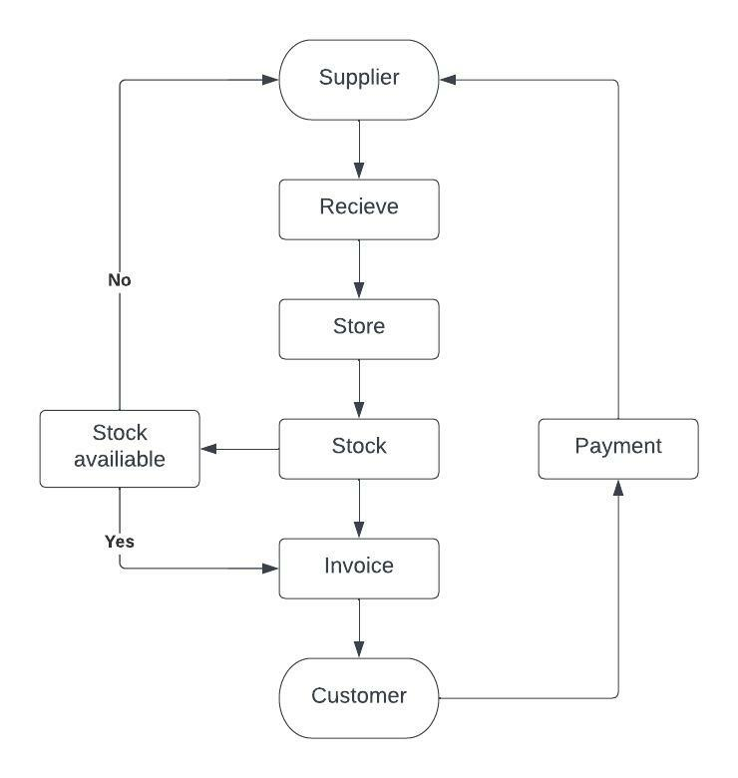

**Business Process Diagram:**

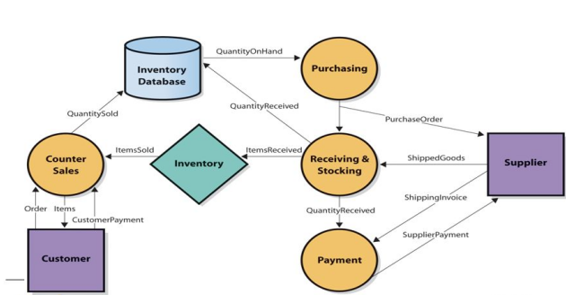

**Link:**

https://lucid.app/lucidchart/b9164010-0fda-4055-acf8-958892695814/edit?viewport_loc=-10%2C301%2C1707%2C835%2C0_0&invitationId=inv_dc426683-f745-4ba4-836c-72b363408b6c#

# Organization Type

Budgens Stores Ltd, doing business as Budgens, is a grocery store chain in the United Kingdom. John Budgen began the company in 1872, opening the first shop in Maidenhead, Berkshire, and it was formed as a private limited company on May 28, 1962. Booker Group, a division of Tesco plc, operates the retail fascia. Until it was destroyed by fire on 20 June 2020, the largest Budgens store was in the town of Holt, Norfolk, with slightly over 13,000 square feet/1,207m. The store's ruins have been dismantled, and a smaller temporary store (housed in a fabric structure) has been built up in the parking lot. The CT Baker group has got planning approval to reconstruct the store precisely as it was before the fire, although construction has not yet begun as of November 2021 The first two Scottish stores debuted in July 2016, having been purchased from the Coop and previously branded as Somerfield and Safeway. They can be found in Paisley and Prestwick. Later that year, the Paisley shop closed. Budgens was named Fresh Foods Convenience Retailer of the Year in the company-owned sector at the Retail Industry Awards in 2006, 2007, 2008, and 2012.

Ethics-compliant firms also foster an environment in which employees feel driven to work. Ethical organisations acquire high integrity, become socially responsible, and think globally. All of this reduces the likelihood of stress, attrition, and dissatisfaction in such firms.

They motivate employees while simultaneously limiting their actions. Strong, clearly expressed values should be a true expression of your organization's ambitions for appropriate workplace behaviour, and they can help you develop a healthy culture.

Retail stores rely on an organizational structure that is divided into three sections: centralized operations, retail operations, and regional operations. Store planning and human resources are examples of centralized operations. The organizational structure of a restaurant establishes the function and obligations of the restaurant's employees, assisting in the alignment of occupations with necessary activities for the restaurant's performance. Importantly, because each restaurant is unique, the structure may vary slightly. Organizational structure is crucial because it directs how your company delivers value to a market. The value chain of your organisation is the sequence of high-level operations that constitutes your primary value-creating process. It is the conversion of a competitive strategy into action. Corporate chains, voluntary chains and retailer cooperatives, consumer cooperatives, franchise organisations, and merchandising are the most common types of retail organisations.

# Hired a new Manager

Provide continuing coaching best practices training. Create criteria for managers to follow and leadership models to follow. Set expectations for how frequently managers should coach and check in with employees. Clarify organisation performance objectives and expectations so that management understand what they are aiming for.

Employees are telling more people who they work for. Increases the frequency with which employees tell others that the organisation is an excellent place to work. Employees are transformed into brand ambassadors. Increase the number of employees who go the additional mile.

The research investigates the manager's role and bases its conceptual model on it. This article demonstrates that managers require role-playing in three areas: training, motivation, and employee engagement to promote employee empowerment and build an empowered atmosphere.

Inventory management has been tainted. Management of Delivery is inefficient. Tax modifications. Consumer Behavior is Changing. Logistics Management in Reverse. encroaching on small towns and communities Marketing Time Restriction and Marketing as a Revenue Source.

Organizing get together outside of work is a terrific way to boost employee and company morale, encourage creativity, and aid in the formation of more focused teams. You should not hold these crucial events if you are unable to participate in these activities in person. New managers are frequently left with no training or expectations for their new position. This can lead to irritation and disengagement among your supervisors, which can undermine team engagement.

One-on-one meetings are an excellent method for managers to recognise each team member for their unique talents and accomplishments, as well as to learn about each employee's personal issues and ambitions. They were absorbed in their task. They are pleased with their organisations as places to work. They are dedicated to their organisation. Willing to promote their company as a great place to work. Employees who believe their company provides exceptional products or services are more likely to stay with the company. Employees are more likely to be proud to work there if they have the necessary decision-making authority and if senior management makes clear decisions.

Employees must be appropriately trained in order to exercise their greater authority and utilising information resources such as the Internet. Assume you are a human resources executive who supports strategy. Empowering employees entails providing them with the authority, technology, systems, and independence to go above and beyond to satisfy customers. Empowering customer service teams necessitates rigorous employee training in order to recognise and act on opportunities to improve the quality of support.

# Heart in Business mission

At Heart in Business, our aim is to "develop people and businesses to their maximum potential for a better society." Our dream is to work for a company that serves a purpose. Companies that contribute more to society and look beyond the next set of quarterly profits. Companies that consider all of their stakeholders, including their employees, community, the environment, and, of course, their shareholders. And where we know that this emphasis will continue to produce excellent returns for shareholders.

Companies that care about the influence they have on people, whether they work for us, are our customers, or reside in the community in which we operate. Companies that tap into their employees' entire human potential. Companies where sincere leadership exists, strategies are co-created, and money flows. Companies where employees may be themselves without fear of being judged or punished. Companies that care about our planet, firms that think about future generations, companies that contemplate what we leave behind for our children and grand kids. This is our vision of how businesses will prosper in the future; in fact, some are already doing so. Indeed, we at Heart in Business Limited think that this is the only way ahead.

Tolerance for uncertainty and the ability to deal with open-ended challenges are acknowledged skills. For example, a knowledge-based engineering system can improve its operational aspect and hence its stability by involving additional subject-matter experts, thereby raising questions of human boundaries. As in, many instances, computational results must be taken at face value due to a variety of reasons (thus the need for the duck test) that even an expert cannot overcome. The final results could be the ultimate proof (reasonable facsimile by simulation or artifact, working design, etc.) They are not assured to be reproducible, may have been time and money consuming to achieve, and so on.

Mappings must be maintained between a real-world object, its abstracted equivalents as specified by the domain and its experts, and the computer models in advanced modelling with the necessary computational support, such as knowledge-based engineering. Mismatches between domain models and their computational counterparts can cause problems with this topic. Techniques that provide the flexible modelling required for many difficult problems must address concerns of identity, type, and so on, which leads to solutions such as duck typing. Many areas with a numeric focus employ various forms of limit theory to circumvent the duck test requirement, with variable degrees of success. However, concerns continue to exist. Cultural considerations have a large impact on business. Employees are best managed based on their values and priorities, which are influenced by culture. It also has an impact on the marketing, sales, and distribution functions. It can have an impact on a company's analysis and choice on how to best join a new market. Corporate culture refers to the attitudes and practices that govern how employees and management interact and deal with outside commercial transactions in a corporation. Corporate culture is frequently suggested rather than explicitly stated, and it evolves organically over time from the cumulative attributes of the people the firm hires.

# Thornton as Leader

Thornton is an Self-assurance is a fundamental component of leadership. A self-assured leader is optimistic about the future and willing to take the risks necessary to attain their personal and professional objectives. competent, committed, and with a strong personality When we accomplish this, our employees benefit, and when they benefit, we all benefit. A strong leader inspires and develops other leaders." "A great leader has a clear vision, is fearless, possesses integrity, honesty, humility, and a laser-like focus." He or she is a strategic thinker who values collaboration.

Andrew's first task on the ground, with two grocery stores, was to invest considerably in Thornton's Budgens' human potential by mentoring some of the staff and leadership team to unleash their creativity at work. A third of the 80 employees were mentored through the Heart Program to explore how they may harness the power of their interests at work in order to gain a sense of pride and empowerment.

It was a risky live experiment. Andrew, on the other hand, was able to learn the consequences of this method almost immediately by directly implementing the concepts he believed in to his retail firm. By 2016, like-for-like sales were up 5%, while surrounding stores' figures were declining, and the average length of service was 54% longer. Today,

They prefer that the supermarket where they shop keep the products in stock at all times. Supermarkets constantly track consumer purchasing trends and maintain specific products in stock at all times. It is also critical that supermarkets keep all of their products in stock at all of their locations. The worldwide food business is expected to generate $1.9 trillion in new sales by 2023, representing a 28% increase over 2018. Grocers, unlike other merchants, confront particular inventory concerns, such as the freshness and availability of produce, both online and on store shelves. Every day, grocery retailers deal with perishable inventory, such as perishable fruit or damaged boxes and cans.

# I as Manager

As a manager, I must be concerned about my employees' personal and professional development, as well as respect their ideas. Managers must assist employees in understanding how their work relates to the organization's mission or purpose. I will Manages employees and plans and evaluates department actions to achieve department goals. Employees are retained by recruiting, selecting, orienting, and training them. Ensures a safe, secure, and legal workplace. Creates opportunity for personal development. I'll be the figurehead, leader, and connector. Managers must serve as symbolic figureheads due to their formal power and symbolic status in their organisations. When individuals are given the opportunity to identify their Clifton Strengths, their supervisors are better able to comprehend the makeup of the organisation as a whole. As the team evolves and grows, they can make challenging and discriminating decisions about who can best fulfil each function. They understand which team members have special strengths and how to arrange them to promote complimentary connections. Knowing employees' Clifton Strengths is useless if managers do not allow them to put their particular talents to use in their daily job. Managers must understand their employees' Clifton Strengths and use that knowledge to establish a team that collaborates and works effectively together. As a manager, I must ensure that each employee understands what is expected of them at work and that they have the materials and equipment necessary to complete their tasks correctly. As Managers I must foster a culture that appreciates genuine recognition for well-done work. Employees are cared for, their personal and professional development is encouraged, and their ideas are valued. Assist employees in understanding how their work relates to the organization's mission or purpose.

As Managers I must establish a team environment in which employees can form genuine, long-lasting connections. Teams comprised of people who can unanimously agree that their manager does these things are successful, period. They have people who understand how to function as a team, employees who respect one an other's abilities and know how to get the most out of one another in order to achieve team success. I will cooperation starts with great leaders who focus on engagement. Create a firm full of these types of managers to build a company full of teams that collaborate to exceed expectations.

Benoliel, P. and Schechter, C., 2018. Teamwork doubting and doubting teamwork. *Improving Schools*, 21(3), pp.225-239.

Bleakley, A., Hobbs, A., Boyden, J. and Walsh, L., 2004. Safety in operating theatres. *Journal of Workplace Learning*, 16(1/2), pp.83-91.

# I as Leader

As a team leader, I oversee a group of individuals, motivate, instruct, and monitor performance. It could be an official title change or a management delegation exercise, but being a team leader distinguishes you from your peers as a trusted individual to manage a project or group of employees. Leaders must have clear goals and objectives, motivate their followers and provide guidance, and assist their team members in order for them to succeed. Each role has obligations that may overlap with those of others. A manager and communicator, for example, both discuss strategy with a team and give verbal directives to execute duties. Team leaders are in charge of training team members, developing strategies, and tracking progress toward goals. Strong communication, problem-solving, organisation, and delegation abilities are required of good leaders.

A strong leader inspires and develops other leaders. A great leader has a clear vision, is fearless, possesses integrity, honesty, humility, and a laser-like focus." He or she is a strategic thinker who values collaboration. As an effective team leader, I coach people on how to achieve goals and develop abilities that produce outcomes. Coaching entails improving team members' performance, providing feedback, and modelling the necessary abilities and work ethic. A coach-style team leader works with its members to help them enhance their talents. It is also my obligation to determine the team's strengths and flaws. You can allocate the necessary responsibilities to the proper person by determining which team member excels at which task. It is also useful in identifying areas for improvement and the proper strategies to take. It is necessary to define success in order to measure team success. Miscommunication can be avoided by evaluating goals and defining how the team will measure performance. This also provides team members with a clear idea of what is expected of them. Setting explicit team goals and assessing progress along the way enables teams to collaborate. Organization is necessary when there are multiple team members working on a single goal. Individual projects, goals, communications and important documents should remain clear and accessible. It is the responsibility of the team leader to organize team meetings, topics of discussion and progress toward the goal. Communication is crucial when working with and leading a team because you will have to communicate with both your team and your supervisors. A team leader communicates in a way that is clear, effective and directive.

Drier, H., Gibers, N. and Pritchard, D., 1977. Expanded Roles, Functions and Responsibilities for Programs of Career Guidance. *Journal of Career Development*, 4(1), pp.3-14.

Gottfredson, L., 1997. Multiculturalism in the workplace. *The Psychologist-Manager Journal*, 1(1), pp.7-17.

# Performance as a Leader

As a leader, I will emphases the importance of organisation when working on a project with several team members. Strong organisation abilities can assist you in monitoring progress and motivating team members. Individual team members must be assigned duties by team leaders. This demands the team leader to have faith in the team's talents. I will set a good example. A team leader with integrity is not only more likely to be trusted by their team members, but they are also often liked and appreciated. Team members frequently emulate the work ethic of the team leader. Instilling confidence in team members can be aided by displaying confidence in the work and the team itself. Before you hire someone, conduct an online search of their web presence, including social media and Google. Then you should schedule an interview with the individual and conduct a more thorough analysis of the individual. Pro-activity is a necessary component of every successful team. Your project is significantly reliant on the joint efforts of all of your team members. Employees that take initiative are valuable assets. To begin, consider the candidate's first interaction pitch. Consider how they approached you at first. Second, evaluate the discussion you had. Over credentials, priorities skills, knowledge, and experience. Never hire purely on the basis of certifications since you risk hiring incompetent and inexperienced project members who will derail your ambitions.

Anwar, H., Ashraf, M., Saqib, M., Ashraf, M. and Ishfaq, K., 2017. https://www.ijser.org/research-paper-publishing-april-2017.aspx. *International Journal of Scientific &amp; Engineering Research*, 8(4), pp.1045-1051.

Martín Rojo, L., 2019. BLOG: CITIZEN SOCIOLINGUISTICS, https://citizensociolinguistics.com/. *Journal of Sociolinguistics*, 24(1), pp.151-155.

# 10.Project or change to wish

The best method to respond to queries about your potential contributions to the organisation is to provide instances of what you have done in the past and tie them to what you can do in the future. The only way to adequately answer this typical interview question is to extensively research the company, function, and industry. You can describe your accomplishments while demonstrating your understanding of what the firm performs during this phase. You can also relate your experience and talents to what the position requires. Make time to speak with employees on major choices, but also ensure that employees feel free to offer any suggestions they may have. You may create a specific technique or time for this to occur, or you could simply develop a culture in which no idea is too foolish and employees feel comfortable innovating in a safe environment.

Share information on what's going on in the organisation with team members, and encourage and enable the sharing of knowledge or skills. Presenteeism reduces productivity as well as resentment and motivation, so do everything you can to discourage this type of culture. Similarly, if employees believe they can work from home, take time off for medical visits, or deal with family matters. A team with high social contact both within and outside of the workplace tends to perform better together, be happier, and collaborate more efficiently. You can help by organisation events such as Christmas parties and summer get-tethers, but you may also encourage more frequent low-key social gatherings like as team lunches, running or cycling groups, cake-sharing, or even a workplace choir. Team-building days away from the office, regular informal meetings, and other strategies that get employees away from their desks and talking to each other can help to establish relationships that make the workplace a pleasant place to work while also resulting in job benefits through better collaboration. Make sure employees know they are doing a fantastic job and that they are recognise for it. That can be as basic as a thank you or a well done for a minor accomplishment, or it can be public thanks in a team meeting, positive comments in a one-on-one, or even an award or a bonus. Consider the level of support you provide to employees, and ensuring that those who require it do so, while others who are happy without it can request it. Prioritize staff growth and training, and make sure that when a team member learns a new ability, he or she can put it to use as quickly as feasible. A high level of autonomy at work is essential.

Nault, W., 1984. A Corporate Leader Looks at America's Educational Dilemma. *Journal of Career Development*, 11(1), pp.42-47.

Swann, J., 2019. Blog: Language: A Feminist Guide. Blog authored by Deborah Cameron, Oxford University, U.K. https://debuk.wordpress.com/. *Journal of Sociolinguistics*, 23(1), pp.105-109.